• Course Number: MSCs3250
• Course Title: Software Design and Architecture
• Term: Fall
• Year: 2025
• GROUP NUmber: 1
• Team Members:
Poorna chandra dinesh
UDAY sai lakshman sanam
uma maheswari chinnam
• Instructor: Firas Khasawneh

AI Multi-Platform Integration Agent

Data Model Requirements
The data model for the AI Multi-Platform Integration Agent is designed to support flexible, secure, and efficient data exchange across multiple platforms such as SharePoint, Google Drive, and PostgreSQL. Given the heterogeneous nature of these data sources, the model focuses on interoperability, metadata management, and temporary caching rather than long-term storage.

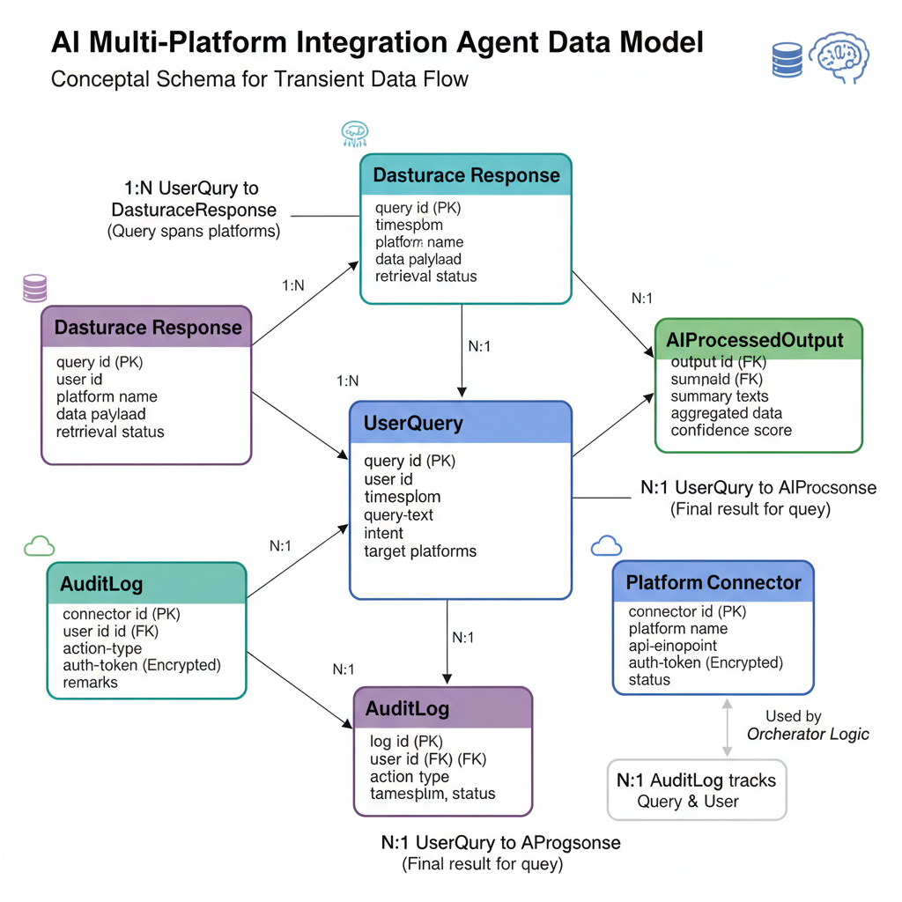

Core Data Entities
The system uses a lightweight and modular schema built around the following key entities:
Entity | Description | Example Attributes
UserQuery | Represents a natural language request submitted by a user. | query_id, user_id, timestamp, query_text, intent, target_platforms
PlatformConnector | Stores information about connected services or APIs (e.g., SharePoint, Google Drive, Database). | connector_id, platform_name, api_endpoint, auth_token, status
DataSourceResponse | Holds raw data retrieved from one or more sources before AI processing. | response_id, query_id, platform_name, data_payload, retrieval_status
AIProcessedOutput | Stores results after the LLM processes and structures the data. | output_id, query_id, summary_text, aggregated_data, confidence_score
AuditLog | Tracks all major system events and user queries for compliance and debugging. | log_id, user_id, action_type, timestamp, status, remarks

Data Flow and Storage Strategy
- Transient Storage:
Redis or an in-memory store will be used for temporary caching of responses and intermediate results to improve response time and avoid redundant external API calls.
- Inter-Service Data Exchange:
All microservices communicate using JSON-formatted payloads, ensuring consistency and ease of parsing across language or platform boundaries.
- No Persistent Data Repository:
Since the system’s focus is on data retrieval and processing, there is no permanent storage of user or business data. Logs and configuration metadata are the only persistent data retained for operational purposes.

Relationships and Dependencies
- A UserQuery may correspond to multiple DataSourceResponses if the query spans multiple platforms.
- Each DataSourceResponse is processed by the AI layer, producing a single AIProcessedOutput.
- The AuditLog maintains references to both query_id and user_id to support traceability and compliance.
- PlatformConnector details are referenced by the orchestrator to determine the appropriate retrieval path for each query.

Data Integrity and Security Requirements
- All sensitive tokens and credentials stored in PlatformConnector are encrypted using AES-256 or cloud key management services (e.g., AWS KMS, Azure Key Vault).
- Data validation is enforced at the orchestration layer before passing information to the AI module.
- The system employs role-based access control (RBAC) to ensure users can only access authorized data.
- Audit logging ensures compliance with privacy standards similar to GDPR by recording query activities without storing sensitive content.

Extensibility Considerations
- The schema is extensible to accommodate new integrations, such as Slack or AWS S3, by adding new entries to PlatformConnector without changing existing relationships.
- The AIProcessedOutput structure can evolve to support new output formats such as structured reports, visual summaries, or insights graphs.

Data Modeling Methodology and Justification

Overview of the Hybrid Methodology

The AI Multi-Platform Integration Agent adopts a Hybrid Data Modeling Methodology that merges Conceptual, Logical, Canonical, and Physical approaches.
This combination enables structured and unstructured data to be modeled consistently while maintaining flexibility, scalability, and interoperability across distributed data platforms (SharePoint, Google Drive, PostgreSQL).

The hybrid approach ensures:

- Standardization of data exchange with a Canonical Data Model (CDM).
- Conceptual clarity and logical integrity through well-defined entities and relationships.
- Scalable, performative data handling via caching and indexing mechanisms.

Conceptual Data Model

This level captures the semantic relationships between essential system entities without regard to database or format constraints. It focuses on how the system’s components conceptually interact to meet business objectives.

Entities and Relationships:

- UserQuery: The initial user request processed by the system.
- PlatformConnector: Abstraction that links external APIs.
- DataSourceResponse: The data outputs returned from platforms like SharePoint, Google Drive, or relational databases.
- AIProcessedOutput: The final structured or summarized output generated by the AI module.

Conceptual Focus:

- Clarifies how different data sources contribute to unified responses.
- Aligns technical components with user and system goals.
- Supports modular understanding of interactions.

Conceptual ER Diagram (Textual Representation):

[UserQuery] 1---< [DataSourceResponse] >---1 [PlatformConnector]
|
| 1
V
[AIProcessedOutput]

This diagram shows:

- One user query can lead to multiple platform responses.
- Each response is tied to a specific connector.
- The aggregated result is processed and delivered by the AI layer.

Conceptual Data Model Block Diagram:

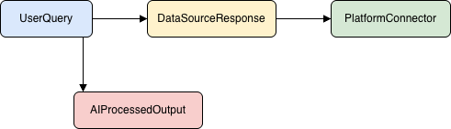

Logical Data Model

The Logical Model provides a structured, database-agnostic representation of how data elements relate, ensuring consistency and integrity through well-defined keys and constraints.

Key Components:

- Primary Key: query_id identifies individual user queries.
- Foreign Keys: Link responses and outputs to their originating queries.
- Normalization: Metadata (e.g., connector settings, API logs) is stored without redundancy.

Logical Design Characteristics:

- Ensures traceability across data processing stages.
- Enables relational consistency even when working with diverse data.
- Allows flexible schema evolution as the system grows.

Logical Structure Diagram (Textual Representation):

TABLE: UserQuery
- query_id (PK)
- user_input
- timestamp

TABLE: DataSourceResponse
- response_id (PK)
- query_id (FK → UserQuery.query_id)
- source_type
- raw_data

TABLE: AIProcessedOutput
- output_id (PK)
- query_id (FK → UserQuery.query_id)
- processed_content
- confidence_score

Logical Data Model Block Diagram:

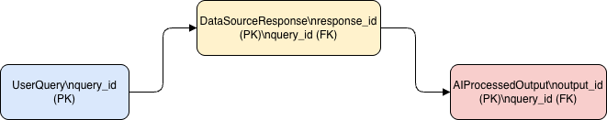

Canonical Data Model (CDM)

The Canonical Model establishes a universal internal representation for data exchanged between heterogeneous systems.
This model acts as an interoperability layer, simplifying integration by transforming data from each platform into a consistent JSON format.

Canonical JSON Example:

{
"title": "Document Name",
"content": "Extracted text or metadata",
"source": "Google Drive",
"timestamp": "2025-11-05T23:00:00Z"
}

Key Advantages:

- Reduces coupling between microservices.
- Standardizes how diverse data formats are understood.
- Facilitates the inclusion of future integrations.

Canonical Transformation Flow (Textual Diagram):

[Google Drive JSON] → [Canonical JSON]
[SharePoint Data] → [Canonical JSON]
[Relational Rows] → [Canonical JSON]
↓
[AI Reasoning Layer]

This ensures that all external data conforms to the same internal representation before AI processing.

Canonical Data Model Block Diagram:

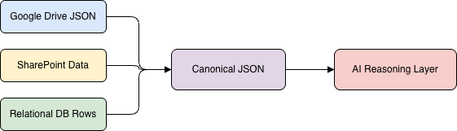

Physical Data Model

The Physical Model defines actual implementation details, including data storage, caching, encryption, and indexing strategies.

Physical Components:

- Redis: Used for in-memory caching of intermediate query results.
- Elasticsearch / Indexed Redis Keys: Accelerates retrieval operations.
- Encrypted Storage: Secures sensitive credentials (API tokens, keys).
- Stateless Architecture: Maintains system scalability by avoiding long-term data persistence.

Physical Architecture Flow (Textual Representation):

[Incoming Query]
↓
[Redis Cache] → [AI Processing Engine] → [Response Delivery]
↑
[Temporary Storage / Encrypted Config Store]

This approach ensures rapid access while securing authentication data and optimizing throughput for concurrent requests.

Physical Data Model Block Diagram:

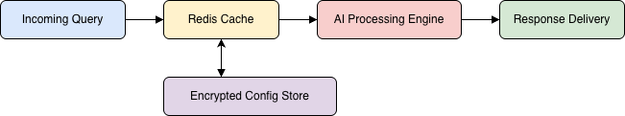

Highlighting the Adopted Data Modeling Approach

Adopted Methodology: Hybrid Data Modeling

Our project adopts the Hybrid Data Modeling Methodology blending Conceptual, Logical, Canonical, and Physical data modeling approaches to handle integration across heterogeneous data sources (SharePoint, Google Drive, and relational databases).

Why This Methodology Was Chosen

- Flexibility

- Canonical Data Modeling is key for normalizing data from different external platforms into a standard JSON format.
- This allows us to easily onboard new platforms in the future without significant redesign.

- Interoperability & Integration

- Logical and Conceptual models ensure consistent relationships and semantics between entities, supporting traceability and reliable data flows.
- Canonical models act as a universal schema making microservices loosely coupled and portable—critical for distributed systems.

- Scalability and Performance

- Physical modeling leverages in-memory caching with Redis and secure credential storage for high throughput and stateless scaling.
- Query and response data do not persist long-term, which boosts efficiency for dynamic, real-time integrations.

- Data Integrity and AI Compatibility

- Logical models enforce strict keys and referential integrity, minimizing data loss and compliance risks.
- The standardization brought by canonical JSON makes it easier for AI components (like LLMs) to understand and summarize incoming data consistently.

Summary Table: Why Hybrid Was Chosen

Methodology Aspect | Adoption Reason
Conceptual & Logical | Clear abstraction, integrity, and traceability
Canonical | Platform-agnostic integration and future flexibility
Physical | Performance, security, and stateless scalability

Hybrid representation of the data model:

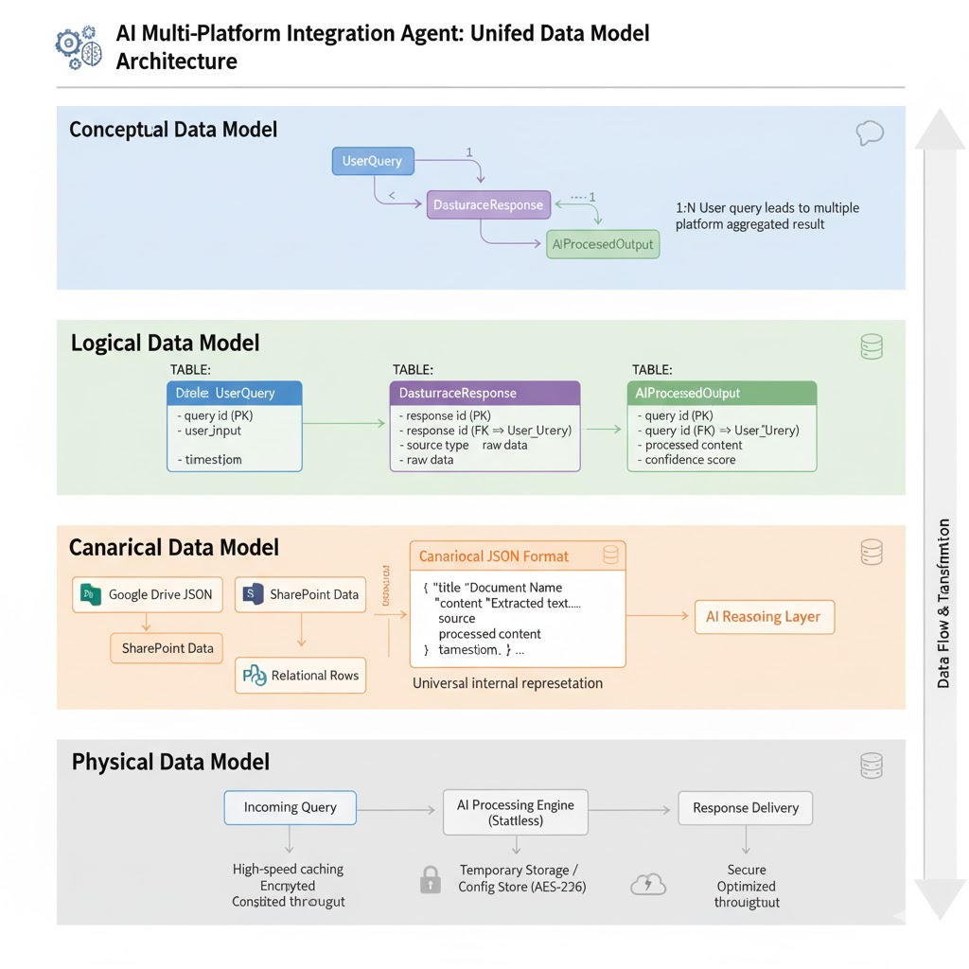

Alternative Approaches Reviewed

Pure Relational Data Modeling
This approach organizes all system data into normalized tables with well-defined schemas and enforces strict relationships using primary and foreign keys.

Strengths:

- Guarantees data integrity through normalization and referential constraints.
- Mature tooling, query languages (SQL), and broad industry adoption.
- Clear entity relationships, supporting reliable reporting for structured data.
Strengths:

- Guarantees data integrity through normalization and referential constraints.
- Mature tooling, query languages (SQL), and broad industry adoption.
- Clear entity relationships, supporting reliable reporting for structured data.

Diagram: Pure Relational Data Modeling

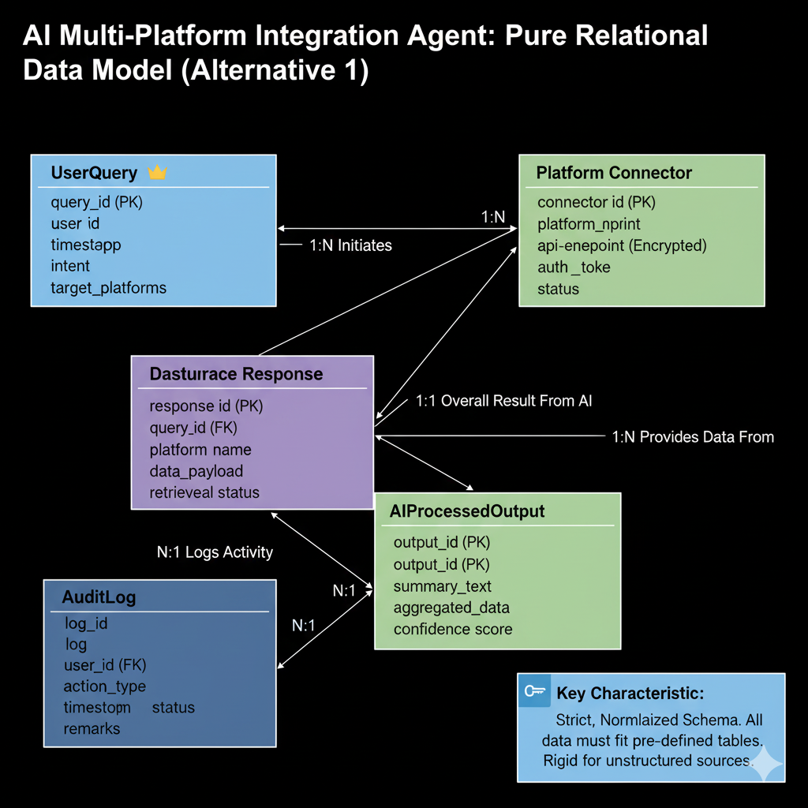

Pure Dimensional Data Modeling

Data is modeled in star or snowflake schemas, separating facts (measures/events) and dimensions (attributes), optimized for fast analytics and data warehousing.

Strengths:

- Excellent for summarizing, aggregating, and trend analysis; enables performance at scale for business intelligence.
- Simplified queries and reporting (OLAP), especially where historical analysis is key

Limitations:

- Doesn’t reflect detailed operational or transactional logic well.
- Difficult to trace granular data back to definitions/origins from unstructured or transactional sources.
- Incorporating new data types or fields can lead to schema bloat or unclear mappings.

Pure Dimensional Data Modeling

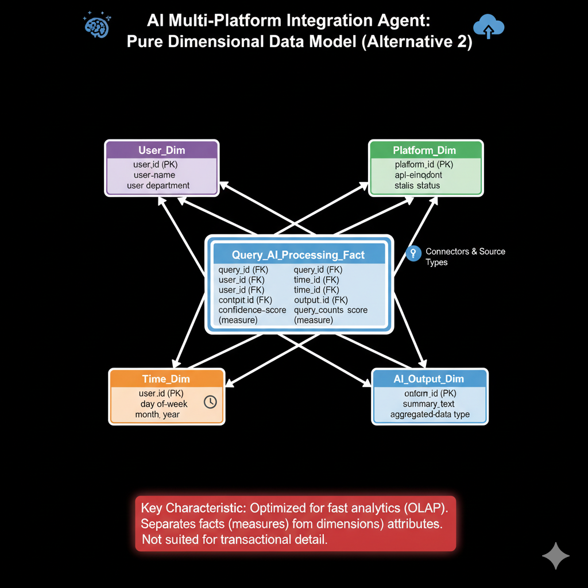

Trade-Off Analysis

Approach | Scalability | Flexibility | Integrity | Real-Time Integration
Relational | Hard to refactor for new sources | Poor handling of unstructured data | Strong (DB constraints) | Slow to adapt, complex mapping
Dimensional | Scales for analytics | Limited transaction details | Moderate | Not suited for real-time ops
Hybrid (Recommended) | Easy to expand/couple new sources | Handles structured/unstructured | Strong (ERM + validation) | Designed for dynamic integration

For our project, maintaining data integrity and traceability was essential, but the unpredictable nature of external APIs especially semi-structured documents required a flexible architecture. The hybrid model offers a pragmatic balance: relational tables ensure traceability, while the canonical/document approach absorbs new data types swiftly.

